The MBA Association (MBAA)

The MBAA is a student-run umbrella organization that provides support for clubs, plans and runs numerous social events through the year such as TG’s, and serves as the liaison between students and faculty, staff, alumni and the Seattle community at large. The MBAA is here to both help you dream big and provide you the assistance you need to achieve those goals. Please feel free to reach out with any questions. We are very excited to welcome the class of 2022!

* MBAA Executive Committee

President  - Liaison between the student body and the MBA Program Office  - Ensure that the MBAA is meeting its short & long-term strategic goals  - Facilitate all MBAA meetings  - Ensure MBAA officers are working toward their goals to serve the Foster community  - MBAA strategic planning and budget allocation |  | Neesha Pinnaduwage*  npinnadu@uw.edu |  |  |  | 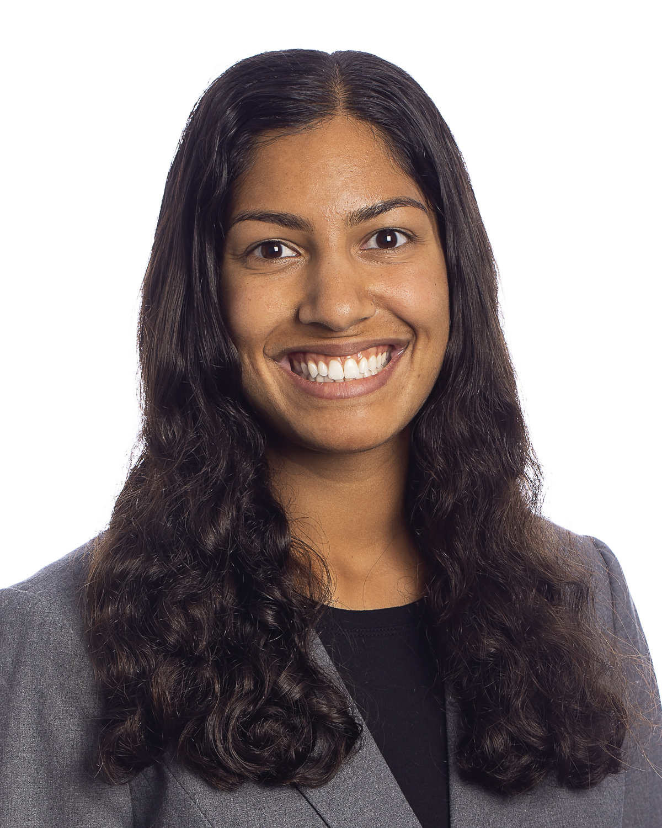
Executive Vice President of Operations  - Provide guidance for and allocate resources to the MBAA club leadership  - Liaison between MBAA student club leadership and the administration  - Serve as President if s/he is unable to perform her/his required duties  - MBAA strategic planning and budget allocation |  | Joey Delgado*  jrd21@uw.edu |  |  |  | 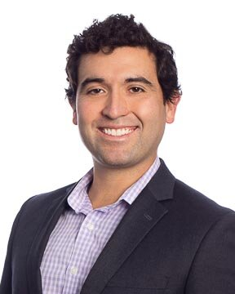
Executive Vice President of Communications  - Maintain calendar of events and oversee the use of MBAA meeting spaces  - Manage the MBAA election process  - MBAA strategic planning and budget allocation  - Communicate with student body about MBAA news, values, and events |  | Claire Herting* cherting@uw.edu |  |  |  | 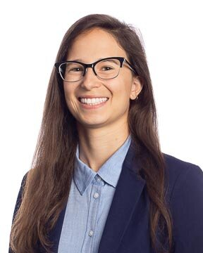
Executive Vice President of Finance  - Manage MBAA finances  - Forecast revenues and maintain budgets  - MBAA strategic planning and budget allocation |  | Kaila Brown*  kbrown3@uw.edu |  |  |  | 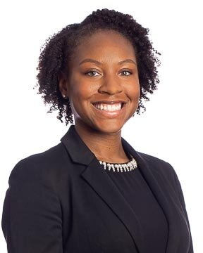
First-Year Section Representative for the Class of 2022  - Serve as liaison between first-year students and the MBAA, faculty, and administration  - Plan and facilitate MBA Class of 2022 Venti sessions, potlucks, and town halls |  | Section A Rep (Open)  Section B Rep (Open)
VP of Academic Affairs  - Facilitate student feedback to faculty on non-core courses  - Student Representative to the Masters Program Committee (help guide the programs offered by the Foster School of Business)  - Conduct polling and presentation of professor awards |  | Sergey Koretskov  skorets@uw.edu |  |  |  | 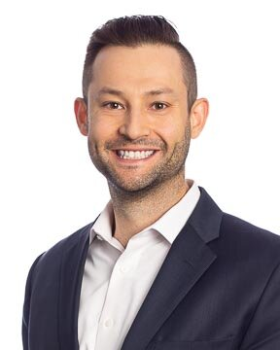
VP of Alumni Affairs  - Oversee class gift fundraising with fundraising committee  - Collaborate with alumni engagement team to plan alumni events  - Serve as class alumni representative upon graduation  First Year Representative (1) – OPEN |  | Praneeth Vempa  pvempa@uw.edu |  |  |  | 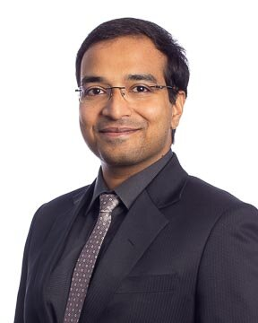
Challenge for Charity President  - Oversee all C4C activities, including leadership team and Advisory Board meetings  - Assist with planning, executing, and promoting volunteer and fundraising events  - Serve as the main point of contact for the Corporate C4C Board  First Year Representative (8) – OPEN |  | Brian Wright  wrighb@uw.edu |  |  |  | 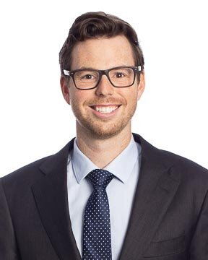
VP of Diversity  - Work with the MBAA, MBA Program Office, & Foster administration to advocate for and support underrepresented groups at Foster  - Support Diversity & Inclusion student clubs in creation and implementation of responsive inclusivity programming  - Promote relationships between Foster and relevant groups in the business community  First Year Representative (2) – OPEN |  | Kelly Yu  kellyyu@uw.edu |  |  |  | 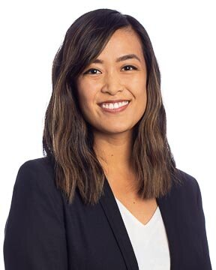
VP of Technology  - Provide technical support for MBAA website and lounge computer  - Provide training and tutorials for school technology resources  - Student support for technical issues or questions  First Year Representative (1) – OPEN |  | Monica Barrera  monicahb@uw.edu |  |  |  | 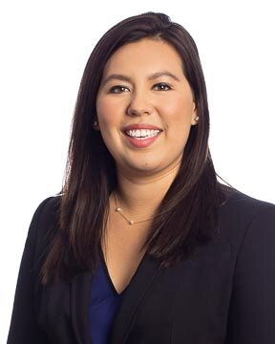
VP of International Affairs  - Organize international student orientation  - Plan international student-focused (and greater community) events throughout the year  - Explore career opportunities for international students with Career Management Office  - Connect Foster international alumni and current students  First Year Representative (2) – OPEN | Prithvi Shankar Ramesh  rameshps@uw.edu  Sihang (Stella) Chen  schen424@uw.edu |  |  |  | 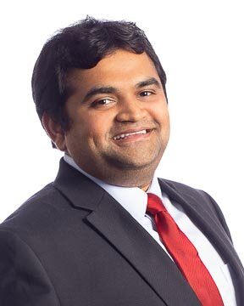  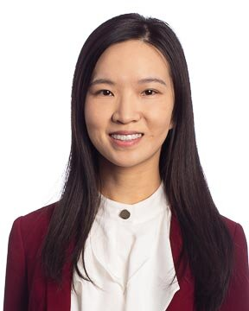
VP of Career Development  - Assist MBA Program Office with orientation programming and events  - Develop big picture strategy to build the Foster brand through broadening our diverse network and leveraging our existing connections  - Meet with MBA Career Management staff to help implement improvements based on student feedback  First Year Representative (1) – OPEN | Devin Doyle  ddoyle1@uw.edu |  |  |  | 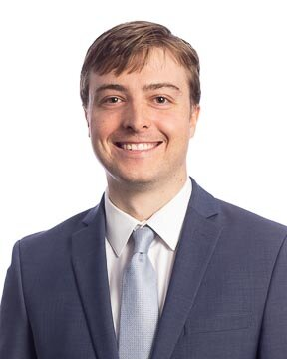
VP of MBA Student Resources  - Work with students and maintenance staff to keep the MBA lounge clean and maintained  - Facilitate a lounge cleaning schedule throughout the school year  - Gather student feedback regarding the MBA lounge and communicate with the Program Office to guide future projects  - Oversee the use, storage, and maintenance of the MBAA supplies | Jack McGarry  jmcgarry@uw.edu |  |  |  | 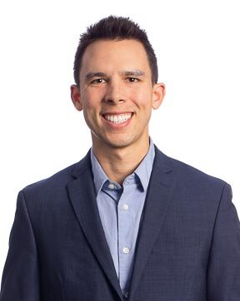
VP of Student Affairs  - Plan and execute MBA Opening Events and quarterly celebrations  - Assist the MBA Program Office with graduation  - Coordinate TGs (monthly student networking events)  First Year Representative (3) – OPEN | Eashita Ratwani  ratwanie@uw.edu  Jessica Hatz  jhatz@uw.edu  Mark Schneider  schneimd@uw.edu |  |  |  | 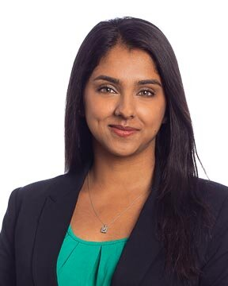  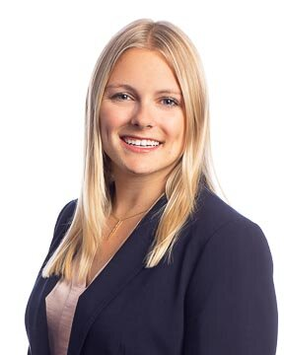  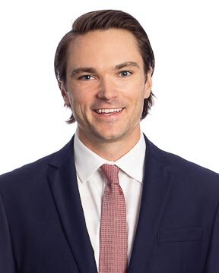
VP of Wellness  - Organize stand-alone wellness events (events are focused on physical health, mental health, and community support)  - Work with Program Office to include wellness programming in school sponsored events (i.e. orientation, LEAD, Pro Dev, etc)  - Regular communication with clubs and Program Office regarding wellness topics | Dailing Chen  dchen11@uw.edu  Camilla Polakoff  cpolakof@uw.edu |  |  |  | 