MBA Global Consulting
International Project Application

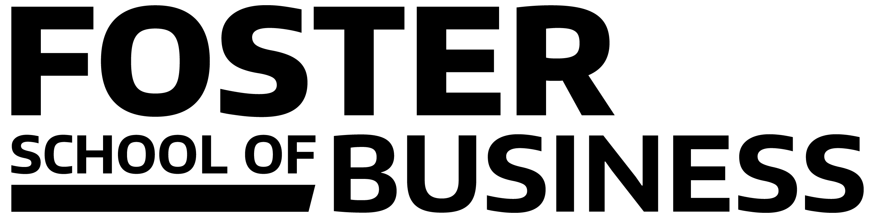

The UW’s MBA Global Consulting program can help your company tackle global business challenges by placing student consulting teams in-country for on-the-ground competitive research.

Real-world consulting projects and global exploration both have a rich history here at Foster. Every year the Global Business Center sends students abroad on study tours and international exchange programs. In the past ten years, our MBA Strategic Consulting Program has conducted hundreds of company sponsored projects involving more than a thousand MBA students. The companies improve their competitive position. The students gain career-building experience while applying their MBA skills in strategy, marketing, supply chain, finance, and organization to create solutions for real-world business challenges. We have combined this consulting and global expertise to create the MBA Global Consulting program.

How Does It Work?
Global consulting projects are conducted in both autumn-winter quarters and winter-spring. They kick off in October and January with the teams’ first meetings with their corporate sponsors (in-person or virtual). The students conduct preliminary research and then spend 10-12 days in-country where they conduct primary research and make an in-depth analysis of the company’s strategic issues in that market. Upon their return to the US, the students complete their research and make final presentations (in-person or virtually) to the sponsor companies. Utilizing their training in strategy, finance, marketing, operations and supply chain management, the teams make recommendations for solving strategic problems, enhancing organizational effectiveness and competitiveness, and exploring and evaluating new global business opportunities.

*There is no fee for this program. Sponsor companies pay air, hotel, per diem and in-country expenses directly related to the project. Maximum amounts to be agreed upon before the project commences.

GLOBAL CONSULTING PROJECT TIMELINE 2018-2019
Activity | October-February Projects | January-May Projects
Application Deadline | September 15 | December 1
Project Kick-Off. Student team meets with project sponsor | October 2018  (In-person or virtual) | January 2019  (In-person or virtual)
Pre-Trip Research | October-November, 2018 | January-February, 2019
In-Country Research | December 8-21, 2018 | March 8-22, 2019
Final Presentations | February 18-28, 2019  (In-person or virtual) | May 13-2, 2019  (In-person or virtual)

MBA Global Consulting
International Project Application

Date:

Company/Organization Name:
Address:
Website:

Primary Contact:
Title:
Phone:
Email:

Secondary Contact:
Title:
Phone:
Email:

Industry:

Contact information is shared with the student team only after they are assigned to the project.

Project Description
Please answer the following questions to describe what you’d like to accomplish by working with a team of our students. We will use this information to determine if the project is a good fit with the program. The students will use it in selecting the projects for which they apply. You will also have the opportunity to talk directly (in-person or virtually) with the students as they consider the projects.

- Country/Region of Interest:

- Functional Area of Project
□ Accounting □ Finance □ Operations or Supply Chain □ Marketing

□ HR/Management & Organization □ Other ______________________

- What is the main question you would like to answer or the business problem you are trying to solve?

- Strategic implication
Please describe the strategic issue(s) that might be addressed with the assistance of the student team. For example, you may plan to use their market segmentation analysis to help determine the marketing budget for a new product launch.

- What other solutions are you currently exploring regarding this issue?
If relevant, please provide some insight as to what (if anything) your company has done to address the business problem. Examples include working with consultants, developing a cross-functional team, increasing budget or resources.

- What resources could you make available to the team to support the project?
Examples include selected customer information, competitor information, survey data, industry reports, internal research reports, financial statements, etc.

- What are your expected deliverables?
The project will conclude with the team presenting their findings and recommendations to you at your office or in a virtual meeting. What would you expect to receive at the final presentation? Examples might include financial modeling tools, marketing plans, competitive landscape assessments, market segmentation analyses, new organizational models, business expansion plans, and market entry strategies.

If a team of MBA students is assigned to your project, their first task will be to meet with you (in-person or virtually) and then write a detailed scope of work and plan which both you and the program will approve before they proceed. Minor changes in the direction and expected deliverables may occur as the project progresses.

Team Requirements

Required Language Capability other than English? Yes ___ No ___

If “No”, please skip the rest of this section.

Language - 1: __________________

Desired ____ Required ______ Skill level (choose one): Conversational___ Fluent____ Native____

Ideally, how many of the four team members should have this capability? _________

Language - 2: __________________

Desired ____ Required ______ Skill level (choose one): Conversational___ Fluent____ Native____

Ideally, how many of the four team members should have this capability? _________

Please email the completed application to: globe@uw.edu

We will follow up to discuss your application and provide further details about the project introduction. Please contact us if you have questions about this application or any other part of the MBA Global Consulting program. Thank you for your interest in working with our students!

MBA Global Consulting
globe@uw.edu 206-221-3533
Michael G. Foster School of Business - University of Washington
Dempsey Hall 334 – Box 353223 Seattle, WA 98195 USA
www.foster.uw.edu/MBAGlobal

Rev. July 2018

